[NextWork.org](https://community.nextwork.org/c/i-have-a-question?automatic_login=true)

# Query Data with DynamoDB



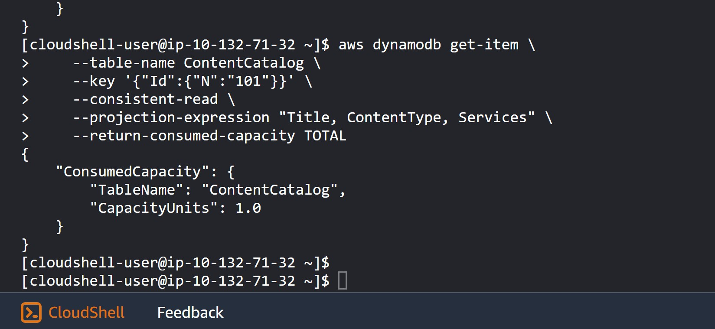

Prajit Venkatachalam

<https://www.linkedin.com/in/prajit-venkatachalam/>



## Introducing Today's Project!

### What is Amazon DynamoDB?

Amazon DynamoDB is a NoSQL database service. It organizes data into tables, with information structured in the form of items and attributes.

### How I used Amazon DynamoDB in this project

In today's project, I used DynamoDB to create and load tables, and I executed queries using the AWS CLI. I also processed transactions, which allowed me to perform multiple operations as a single unit to manage related data.

### One thing I didn't expect in this project was...

One thing I did not expect in this project was that DynamoDB queries must use the partition key. I encountered an error in scenarios where I tried to find data using only other attributes.

### This project took me...

This project took me 3 hours to complete include documentation.



## Querying DynamoDB Tables

A partition key is the main tag/ID that DynamoDB uses to partition its table items. Every item must have a partition key, and the partition key's value must be unique unless the table also has a sort key.

A sort key is a secondary filter that DynamoDB uses to search for specific items. Each item's primary key is made up of its partition key and sort key in a tabel. This means partition key values can be the same as long as the sort keys are different.

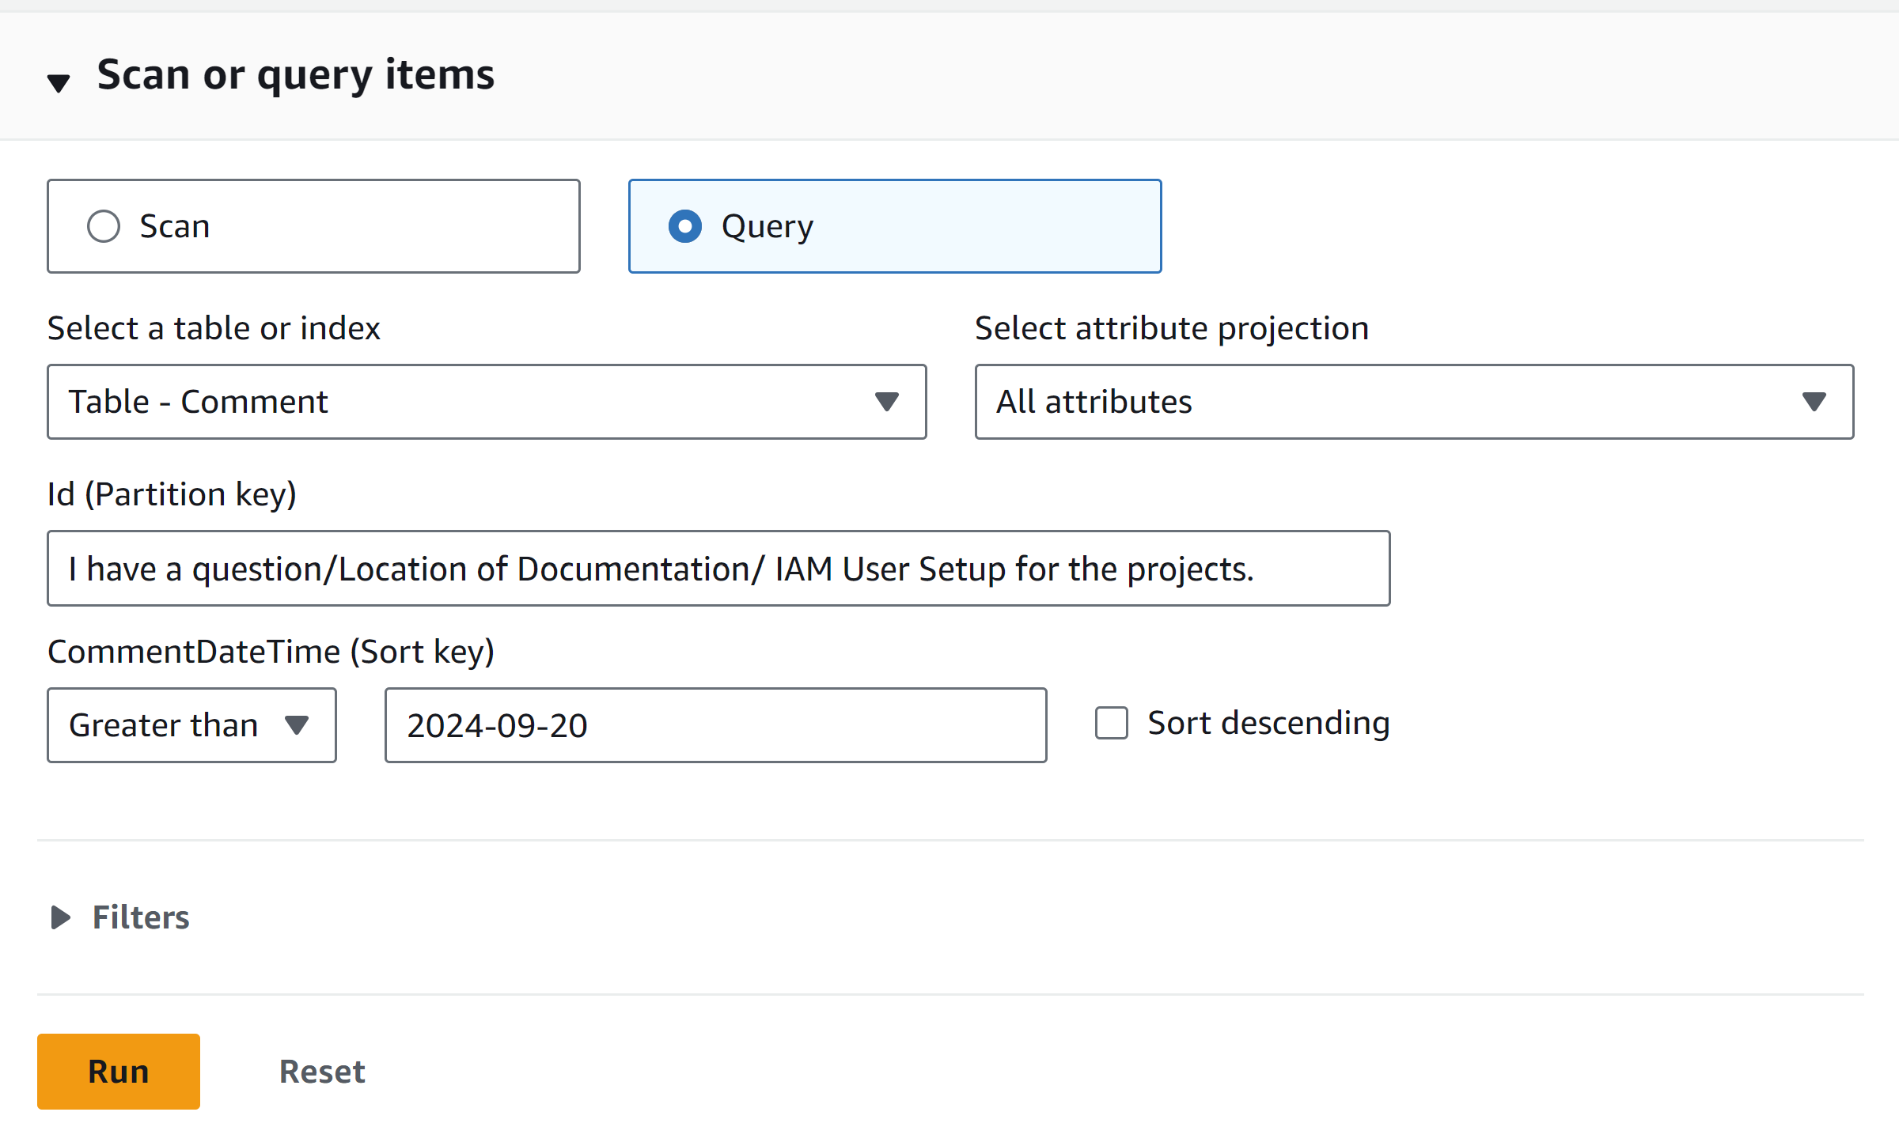



## Limits of Using DynamoDB

I encountered an error when I queried for all comments made by a specific user. This happened because queries must use the table's partition key, and the 'PostedBy' attribute, which I used to query the data, was not the partition key.

Insights we can extract from our Comment table include all comments left on a single post, and even sorted filters by comment time and date. However, insights we can't easily extract from the Comment table include comments made by a specific user.

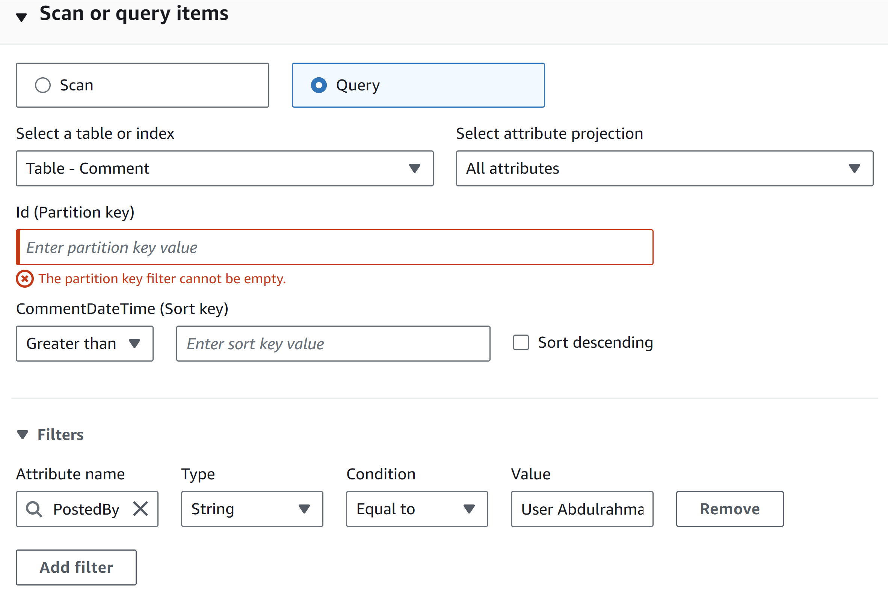



## Running Queries with CLI

A query I ran in CloudShell was aws dynamodb get-item. This query retrieves an item from the table using the partition key value specified in the command.

Query options I could add to my query include consistent-read, which provides a strongly consistent read, projection-expression, which returns only specified attributes, and return-consumed-capacity, which shows the number of capacity units consumed.

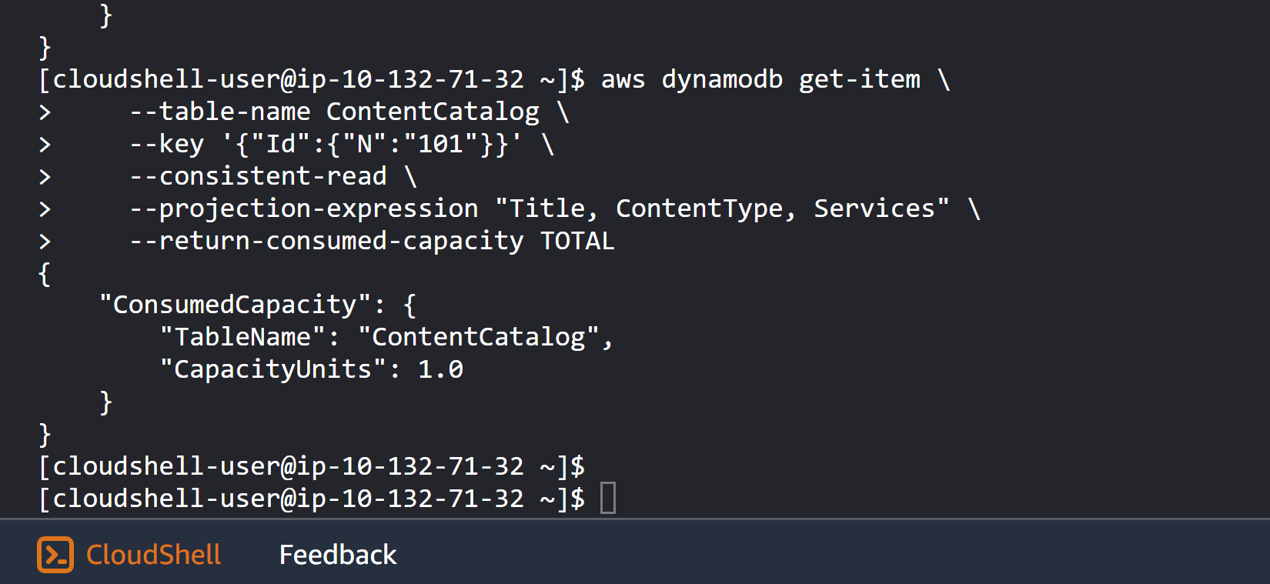



## Transactions

A transaction is a group of operations that are bundled together and executed as one. For a transaction to succeed, all operations within that transaction must be processed successfully.

I executed a transaction using AWS CLI commands in AWS CloudShell. This transaction performed two actions: first, it added a new item to a table, and second, it updated an item in the Forum table by increasing the event's comment count by 1.

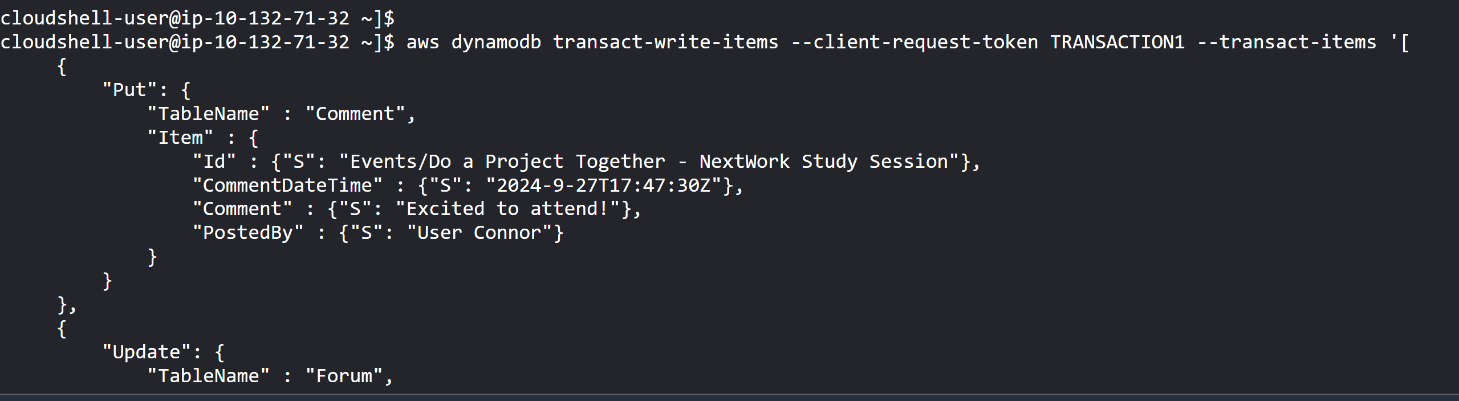

[NextWork.org](https://community.nextwork.org/c/i-have-a-question?automatic_login=true)

# Everyone should be in a job they love.

Check out [nextwork.org](https://community.nextwork.org/c/i-have-a-question?automatic_login=true) for more projects